Exp-3-Writing Basic SQL Select Statement

**1. The following statement executes successfully.**

**Identify the Errors**

**SELECT employee_id, last_name**

**sal*12 ANNUAL SALARY**

**FROM employees;**

Ans:SELECT employee_id, last_name,salary*12 as ANNUAL_SALARY FROM employees;

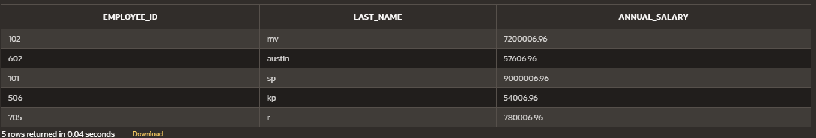

**Queries**

**2. Show the structure of departments the table. Select all the data from it.**

Ans: desc dept;

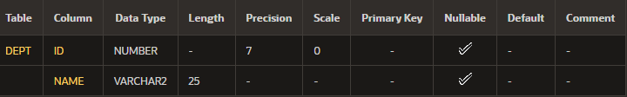

insert into dept (id,name) select employee_id,first_name from employees;

select * from dept;



**3. Create a query to display the last name, job code, hire date, and employee number for**

**each employee, with employee number appearing first.**

Ans:select employee_id,last_name, job_id, hire_date from employees;

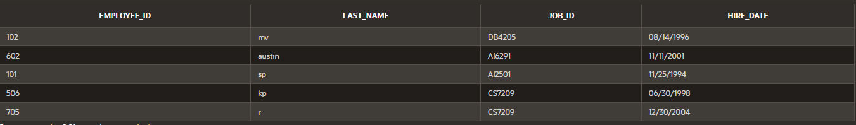

**4. Provide an alias STARTDATE for the hire date.**

Ans:alter table employees rename column hire_date to startdate;

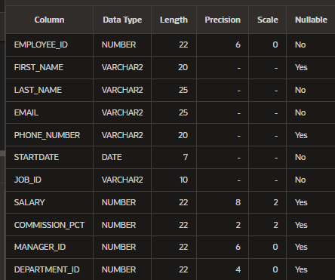

**5. Create a query to display unique job codes from the employee table.**

Ans:select distinct job_id from employees;

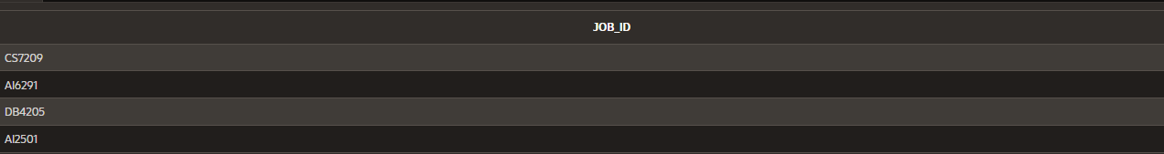

**6. Display the last name concatenated with the job ID , separated by a comma and space,**

**and name the column EMPLOYEE and TITLE.**

Ans:select last_name || ',' || job_id as EMPLOYEE_TITLE from employees;



**7. Create a query to display all the data from the employees table. Separate each column by**

**a comma. Name the column THE_OUTPUT.**

Ans:select employee_id || ',' || first_name|| ',' ||last_name|| ',' || job_id as output from employees;

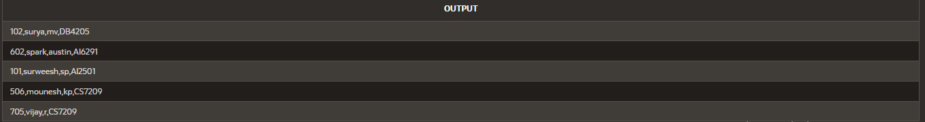

**History:**

